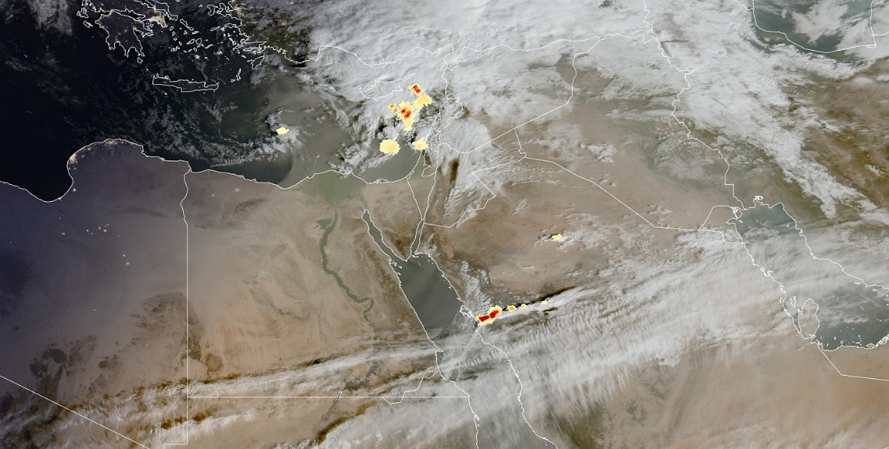

Lab – Routing flights with help of the MTG lightning data

- Open the EUMETView viewer: https://view.eumetsat.int/productviewer?v=40876
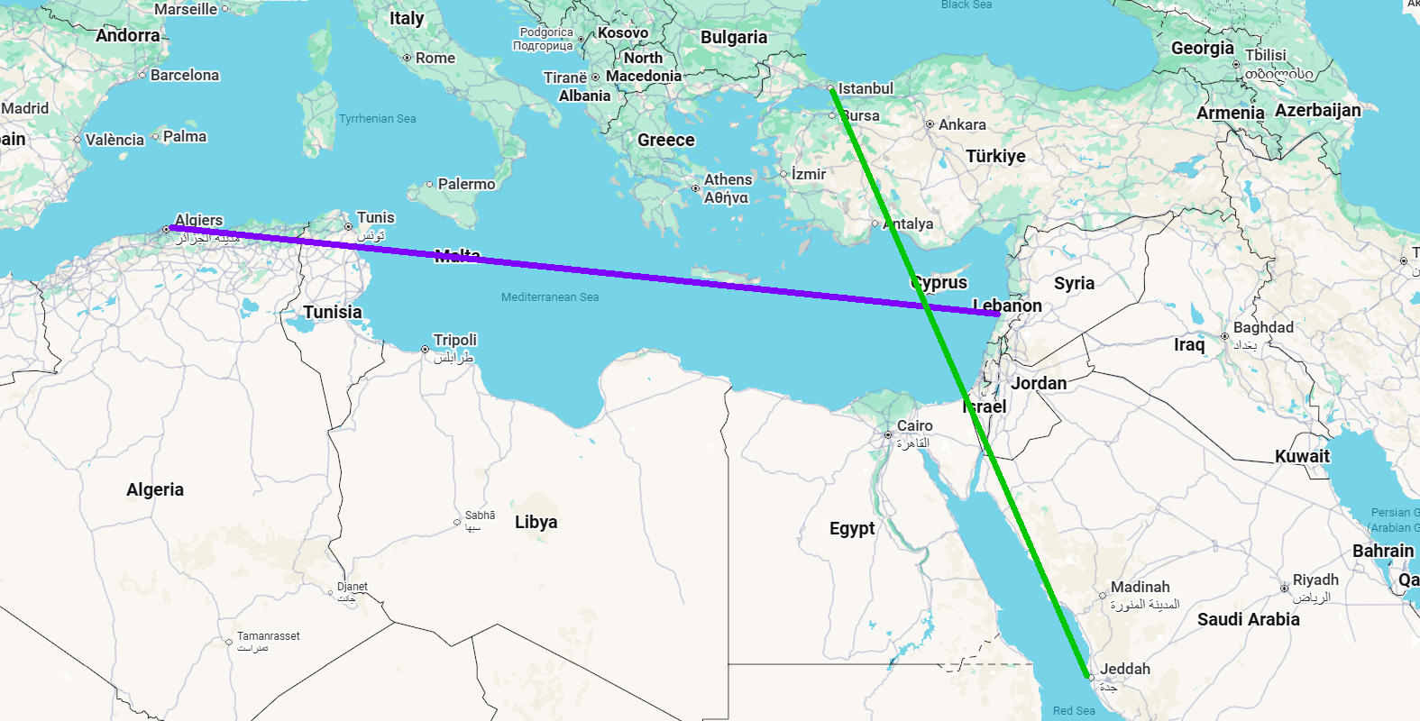
- Focus on the entire MENA region in the 3-day period 22-24 January 2026

- The task: monitor thunderstorms en-route and suggest route corrections for two flight campaigns based on analysis of satellite imagery only: cargo planes Algiers – Beirut, and scientific flights Istanbul-Jeddah (in-flight validation of newest radar detector). There are several consecutive airplanes flying around these routes (Case A-E). Pay attention to severe weather at any given point of the route, at specific case times. Note:

  - Cargo airplanes are willing to accept adjusted routes to avoid severe weather and associated lightning activity,
  - Research airplanes are willing to deviate from direct routes (few hundred kilometres) to come closer to observe the most severe weather systems along the route (however to stay at safe distance, ca 50 kilometres from the storm).

- Detailed instructions for Day 1 to Day 3:
  - Set the date at EUMETView to following dates:
    - Case A: 2026-01-22T0010 (22 January 2026, 00:10 UTC)
    - Case B: 2026-01-23T0030
    - Case C: 2026-01-23T0900
    - Case D: 2026-01-23T2015
    - Case E: 2026-01-24T0740
  - For each given case/time moment, to determine the favourable flight route, please use only the following four layers from EUMETView:
    - FCI HRFI IR10.5 μm Image - MTG - 0 degree (colour enhanced if prefer)
    - True Colour RGB - MTG - 0 degree
    - Cloud Phase RGB - MTG-I - 0 degree
    - LI Accumulated Flash Area - MTG - 0 degree
  - (In Powerpoint or similar, even free-hand on paper) draw/sketch a favourable routes for the two flights in a following order(!):
    - Based on IR10.5 image only, draw the best possible routes for both flights (important is not to open any other layers at this point)
    - Now open also True Colour RGB (daytime only) and see if you would like to correct your route now (sketch a corrected route if you wish)
    - Now open also Cloud Phase RGB (daytime only) and see if you would like to correct your route now (sketch a corrected route if you wish)
    - Finally, open the LI Accumulated Flash Area (pay attention both to density of the lightning events, and also spatial extent of LI detections) - see if this new piece of information gives you better hints on more optimised routes (in which case please sketch the corrected routes again over existing ones).
    - Now try to move imagery in time, scan by scan back and forth around given time for each case (for instance 1 hour backward and forwards in 5 min increments, time step of LI AFA product) – would you like to sketch again more optimised routes for each flight?

  - Example: This is how your imagery could look like (you can download your imagery from EUMETView and sketch directly over it) – in this example original routes are in dash lines (fist attempt to draw) and corrected ones in full lines:
